Test Application Design

PT. XYZ adalah sebuah perusahaan fintech yang ingin mengembangkan mobile apps mereka, dalam upaya menjangkau pengguna yang lebih luas mereka ingin mengembakan aplikasi pinjaman online.

Potential High Level User Story:

* User melakukan registrasi dengan data dir,emaili, nomor telepon dan upload foto beserta KTP
* User dapat login dengan password atau biometric (jika ada di perangkat mobilenya)
* User dapat melihat Sisa hutang dan tagihan perbulan yang harus di bayarkan (Jika ada)
* User dapat meminjam uang paling besar Rp. 12.000.000 dengan tenor maksimal 1 taun.
* User dalam proses peminjaman akan di proses dengan hasil diterima atau ditolak
* Jika pinjaman diterima maka akan ada notifikasi lewat email dan nomot telepon yang terdaftar
* User tidak dapat melakukan peminjaman uang jika sedang ada proses peminjaman dan belum di lunaskan.

Tugas Anda:

1. Buatlah high level design architecture atas project mobile apps ini.
2. Spesifikasikan design Screen Flow dan ERD atas rancangan yang ingin anda buat.
3. Buatlah detail design untuk API dengan menggunakan tools design seperti UML, ERD,flowchart etc.
4. Buatlah detail design untuk screen behavior dari mobile apps berdasarkan screen flow diatas.
5. High level design Architecture

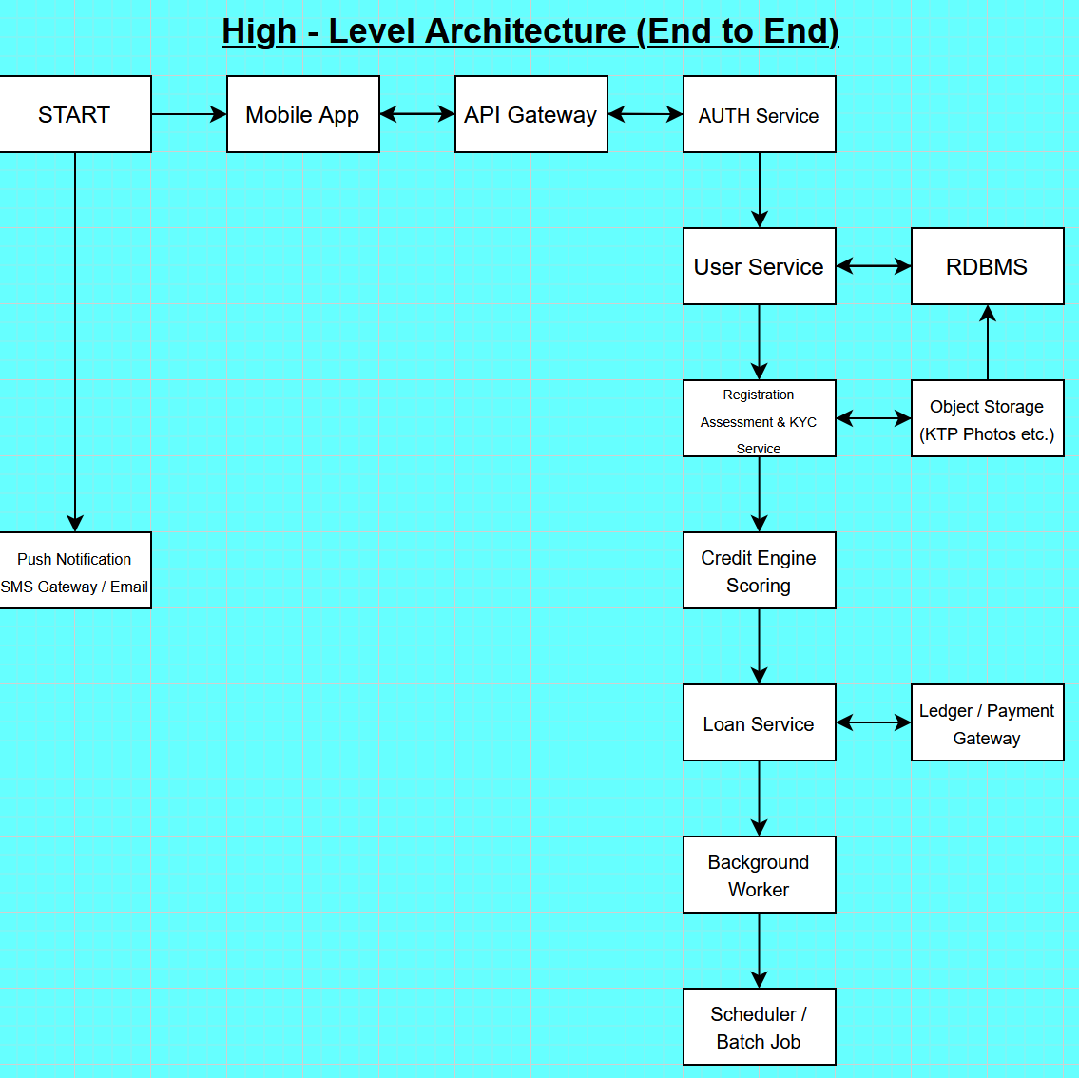

1. Spesifikasi design screen flow

* Mobile App (IOS/Android) – UI untuk user, local biometric, client-side validation, secure storage.
* API Gateway / WAF – rate limiting, routing, TLS Termination, protection
* AUTH Service – login / password + biometric unlock handled
* User Service – Profil user, phone, email verification, KYC metadata pointer
* KYC Service – store & verify KTP + liveness check integration
* Object Storage — S3-compatible untuk foto KTP, selfie.
* Credit Engine / Scoring — scoring (rules + ML model) menentukan approve/reject terisolasi.
* **Loan Service** — create loan, lifecycle (pending, active, repaid), schedule amortization.
* **Ledger & Payment Gateway** — integrate bank/payment provider for disbursement & repayment.
* Background Workers (e.g., Celery, Spark streaming) — process async tasks: notify, scoring retrain, reconcile.
* Scheduler (Airflow) — recurring jobs (generate bills, settle interest).

1. detail design untuk API dengan menggunakan tools design

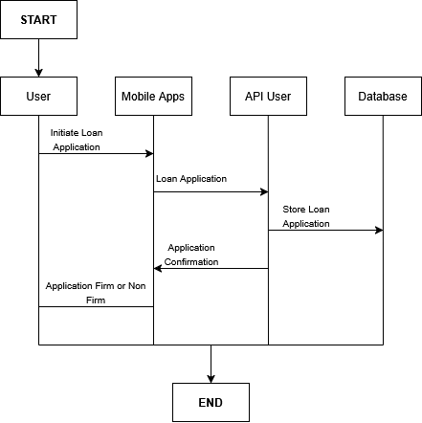

1. Detail design untuk screen behavior dari mobile apps
2. Splash Screen

* Check auth token. If exists & valid → Dashboard. Else → Welcome.

1. Welcome / Onboarding

* Buttons: Login, Register.
* Short intro slides (optional).

1. Register (KYC Step 1)

* Form: full_name, email, phone, dob, password, confirm password.
* Buttons: Send OTP (phone), Verify Email OTP.
* Client validation.

1. Upload KTP & Selfie (KYC Step 2)

* Capture / upload KTP photo (front), selfie (liveness optional).
* Preview + retake.
* Option: auto OCR previewed fields (fill name, nik).

1. Registration Complete / Waiting for Verification

* Show status: KYC pending / under review.

1. Login Screen

* Email/phone + password.
* Option: Biometric toggle (if device supports).
* Forgot password link.

1. Dashboard (Home)

* Greeting, available credit limit, max loan amount, outstanding loans summary (if any), next due date & amount.
* CTA: Apply Loan (disabled if pending/active existing).

1. Loan Application Screen

* Input: amount slider (min..max up to 12,000,000), tenor (months up to 12), purpose (dropdown).
* Real-time preview: monthly installment estimate.
* Submit → Confirmation modal with T&C and consent (electronic signature).

1. Loan Status Screen

* If pending: show status, estimated decision time.
* If approved: show amount approved, disbursement details, repayment schedule (list of repayments), CTA: Accept Disbursement (if manual).
* If rejected: show reason codes (if available).

1. Repayment Screen

* Show upcoming due(s), pay now via integrated payment, history.

1. Profile & Documents

* View/update personal info, documents, verification status.

1. Notifications / Messages

* Inbox for system messages (like approval emails, SMS logs).

1. Settings

* Biometric toggle, change password, logout.

1. Support / Contact

* Help center, call center, dispute.

**PRODUCT CONFIGURATION**

|  |  |
| --- | --- |
| **ITEMS** | **VALUE** |
| App Name | Digital Loan XYZ |
| Website | [www.xyz-loan.com](http://www.xyz-loan.com) |
| Date Release | 15 October 2025 |
| Amount Loan Minim | Rp. 1 |
| Amount Loan Max | Rp. 12.000.000 |
| Interest Rate | 1% - 10% (base request business team) |
| Late Fee | 0.10% / day (base request business team) |
| Admin Fee | 5% disbursement |
| Periode | 12 Month |
| Repayment Type | Monthly Settlement |

**Journal List Finance and Core Banking**

* 1. API – Disbursement to other Bank

|  |  |  |  |
| --- | --- | --- | --- |
| Debet | Giro Internal XYZ | 100xxxx | Rp. 12.000.000 |
| Kredit | Prima / Rintis Transfer | 200xxxx | Rp. 12.000.000 |

* 1. Manual Transfer from Operational Team

|  |  |  |  |
| --- | --- | --- | --- |
| Debet | Giro Internal XYZ | 100xxxx | Rp. 12.000.000 |
| Kredit | Giro BI (BI – FAST) | 200xxxx | Rp. 12.000.000 |

* 1. Repayment API

|  |  |  |  |
| --- | --- | --- | --- |
| Debet | Payment VA XYZ | 100xxxx | Rp. 2.500.000 |
| Kredit | Rekening Loan Debitur | 200xxxx | Rp. 2.500.000 |

* 1. Repayment Manual

|  |  |  |  |
| --- | --- | --- | --- |
| Debet | Limit Teller | 100xxxx | Rp. 2.500.000 |
| Kredit | Rekening Loan Debitur | 200xxxx | Rp. 2.500.000 |